

How to debug a REST API?

PY’s Bonita Tutorial 2020

Github:

<https://github.com/Bonitasoft-Community/pytutorial/tree/master/09%20Debug%20a%20REST%20API%20Extension>

Table of content

1. Configure the portal to accept the debugging 3

2. Create your REST API Extension 4

3. The IDE Project (Eclipse) 4

4. Set up the debugger 6

5. Make a change? 7

# Configure the portal to accept the debugging

First, configure the Bonita studio to accept a remote debug session

Click on “Edit > Preferences”:

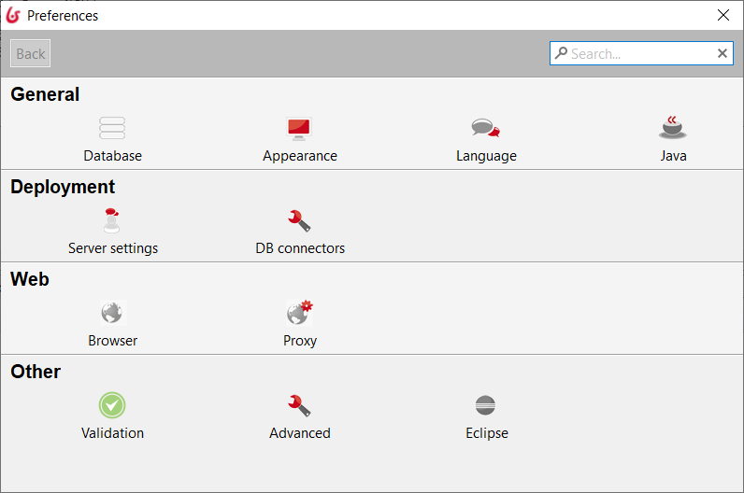

Clicks on “Server Settings”

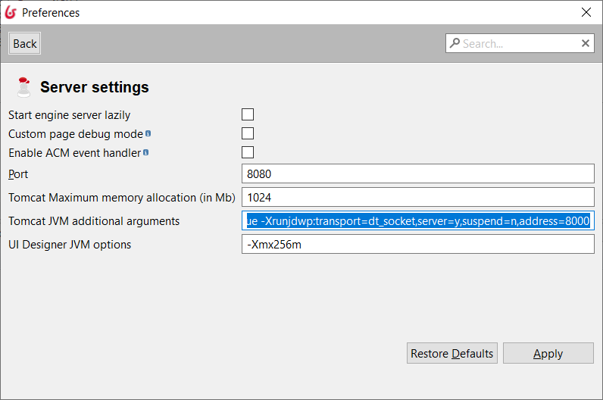

Add this part in the “Tomcat JVM additional arguments:

-Xrunjdwp:transport=dt_socket,server=y,suspend=n,address=8000

Server has to be restarted.

# Create your REST API Extension

Using the Bonita Studio Subscription, you can create a REST API Extension. You can develop the REST API extension outside of the Bonita Studio too, then import it in the Portal.

Find in the GITHUB PY’s Tutorial <https://github.com/Bonitasoft-Community/pytutorial>, and example of the PyDivider REST API:

<https://github.com/Bonitasoft-Community/pytutorial/blob/master/09%20Debug%20a%20REST%20API%20Extension/PyDivider.bos>

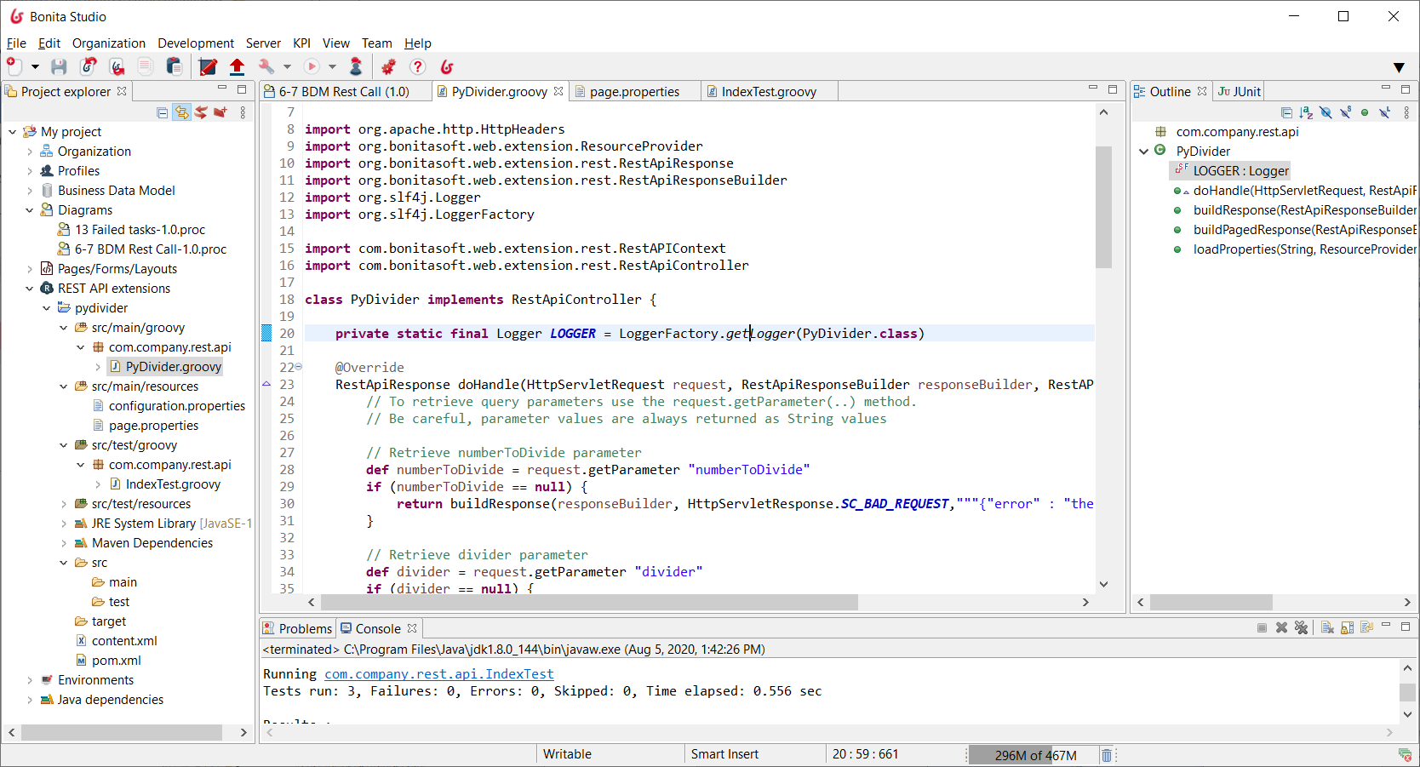

# The IDE Project (Eclipse)

Run a IDE like Eclipse. Attach the Bonita Tomcat process.

Create a Java Project and set the path in <STUDIO>/workspace/<MyRepository>/restAPIExtensions/pydivider.

It’s important to check in the Java Build Path properties that the Groovy Path is correctly visible, else you have to add it.

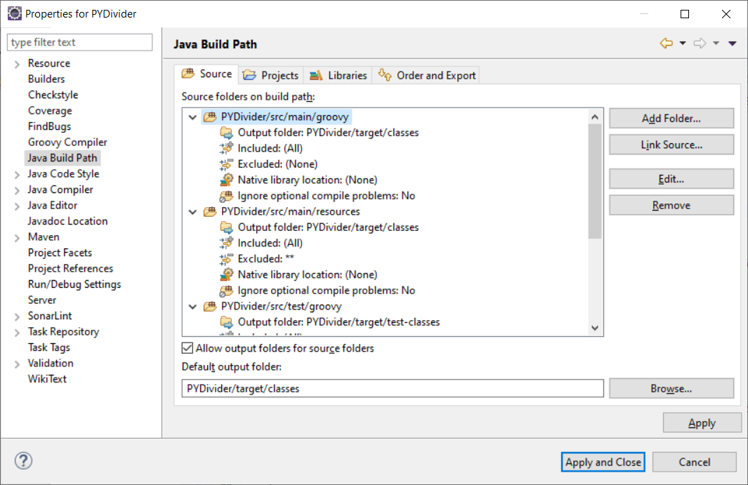

Then, it’s possible now to see the source code, and set a breakpoint on a line:

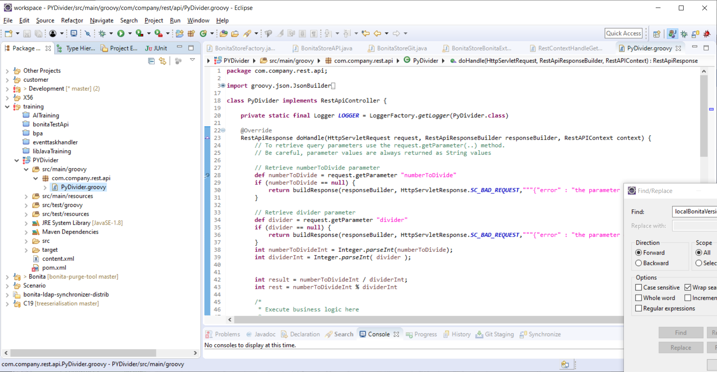

Set up the debugger

Go to Debug>Configuration and add a new “Remote Java Application” configuration:

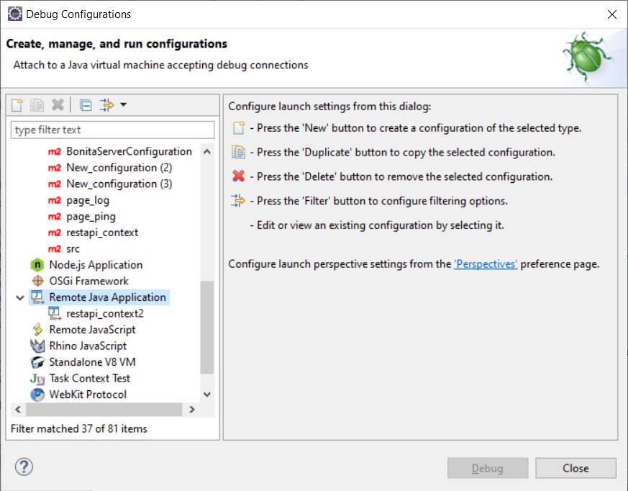

Give a name, and set the Connection properties : localhost and 8000 (this is the port number you gave at the Tomcat configuration):

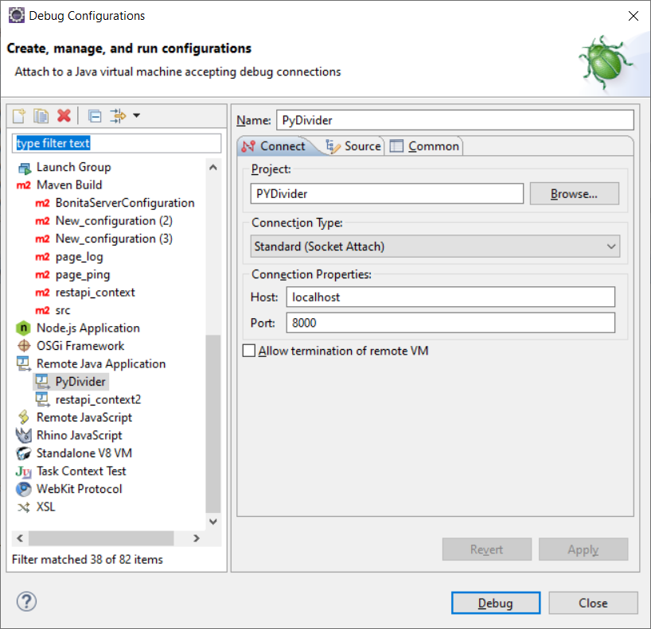

Now, back to the browser, run again a new request. Eclipse jump to the Debbuger Perspective, and then you can see your source code. You are ready to debug!

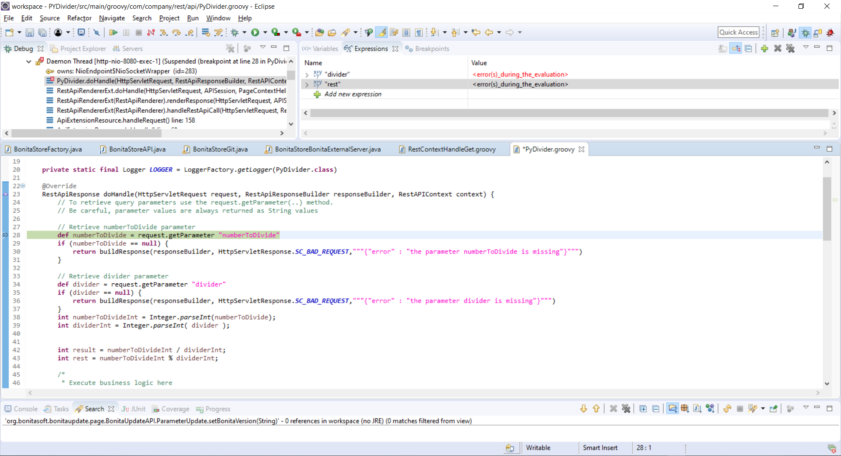

# Make a change?

You can edit your source code on Eclipse. But if you want to see the change, you have to redeploy the REST API Extension on the Bonita Portal, else, due to the cache mechanism, you will not see any change.